First Aid Kits Available:

- 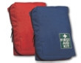

Basic First Aid Kit
R 160.00

Basic Vehicle First Aid Kit
R 160.00
- 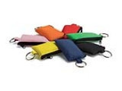

CPR Pouch Complete
R 30.00
- 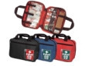

Essential First Aid Kit
R 220.00
- 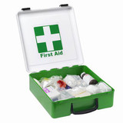

Government Regulaion 7 First Aid Kit
R 450.00
- 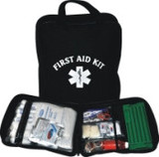

Government Regulaion 7 First Aid Kit
R 400.00
- 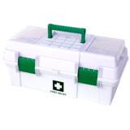

Government Regulation 7 First Aid Kit
R 800.00
- 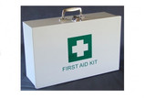

Government Regulation 7 First Aid Kit
R 900.00

Home/Motorist First Aid Kit
R350.00
- 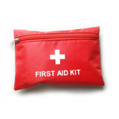

Maxi First Aid Kit
R 100.00
- 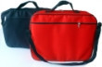

Sports First Aid Kit
R 1050.00

