Jump Bags:
- 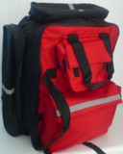

ALS Jump Bag Complete with Stock
R 6550.00
- 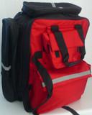

ALS Jump Bag Only
R 1200.00
- 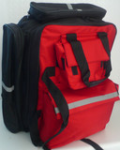

Basic BLS Jump Bag Fully Stocked
R 4200.00
- 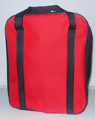

Basic BLS Bag Fully Stocked
R 1850.00
- 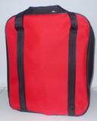

Basic BLS Bag Only
R 550.00
- 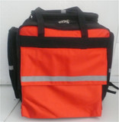

Basic ILS Bag Fully Stocked
R 1550.00

- 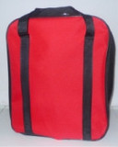

BLS Jump Bag (Basic)
R 1950.00
- 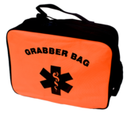

Grabber Bag - 6 Pocket
R 550.00
- 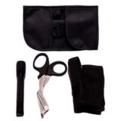

Hip Holster
R 180.00

- 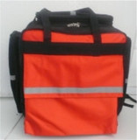

ILS Jump Bag Only
R 1100.00

ILS Paramedic Jump Bag
R 4600.00

ILS Paramedic Jump Bag
R 3600.00

Mini Grabber Bag - 5 Pocket
R 300.00
- 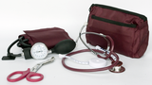

Nurses/Medic Kit
R 400.00
- 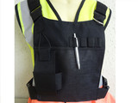

Radio Chest Harness
R450.00

